### Second Approrach option

Variables and Types of Data Structures:

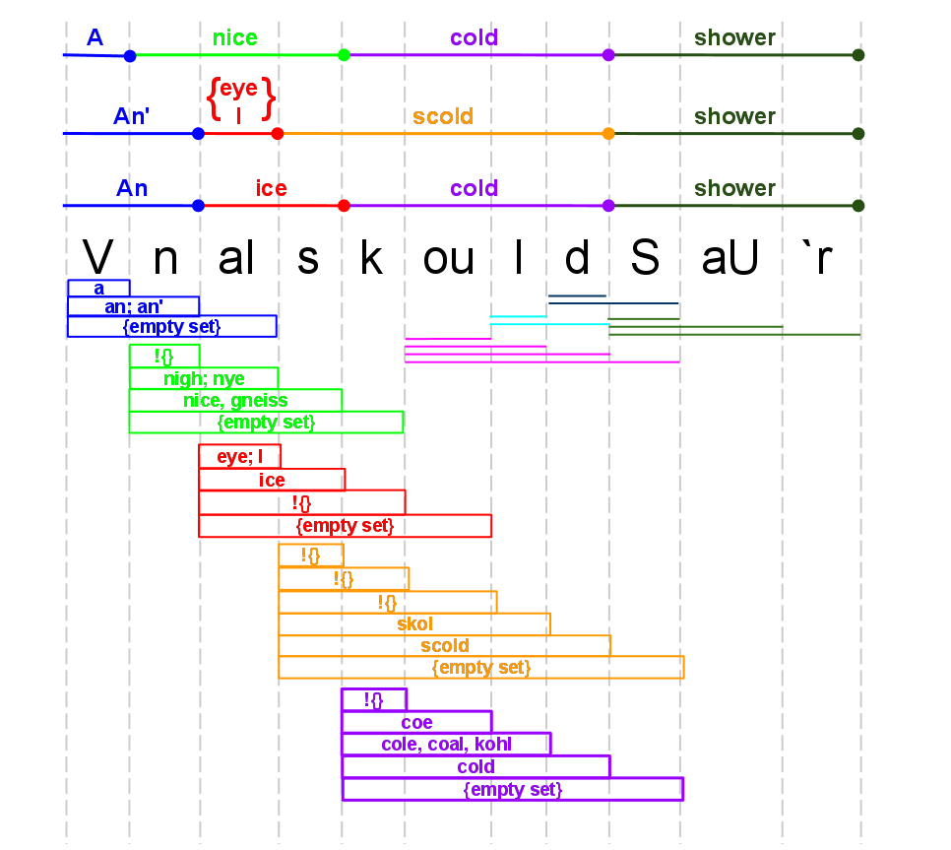origPhonePhrase: The lyrics of the song, broken down into phonemes. (Could be encompass all the lyrics, or just a lyric segment)

allPhoneSubPhrases: A list of phoneSubPhrase structures. There's one structure per phoneme in the origPhonePhrase.

phoneSubPhrases: Per phoneme in the origPhonePhrase, create a phoneSubPhrase structure. In this structure, for each phone following the phone that is the basis for that phoneSubPhrase, concatenate them to create a phoneSubSubPhrase. Stop adding phones when the interpretation of the phoneSubSubPhrase is the empty set.

|  |  |  |  |
| --- | --- | --- | --- |
| **PhoneSubPhrase for "V"** (basically a list of phones and their associated likelihoods) | | | |
| **Phoneme** | V | n | aI |
| **Complete matching words** | a (freq = 7536297) | an (freq = 794169)  an' (freq = 794169) | {empty set} |
| **# of words that are prefix-ed with this** | ####### | ####### | ####### |
| **Likelihood of hearing this as a prefix or as complete** | weighted ratio of (sum/avg of frequency of all matches) to ( sum/avg of frequency of all prefix-ed words) | weighted ratio of ( sum/avg of frequency of all matches) to ( sum/avg of frequency of all prefix-ed words) | weighted ratio of ( sum/avg of frequency of all matches) to ( sum/avg of frequency of all prefix-ed words) |

(We'll eventually compute the likelihood of aural interpretation of each subsubphrase and store it in this data structure / use this data structure to see which aural interpretation is most likely).

For each phone P in origPhonePhrase:

Construct a phoneSubPhrase structure.

set phone S = P

add phone S to the phoneSubPhrase structure

set i = 0

clear list-of-partial-matches

while (there is a partial or full dictionary match for phoneSubPhrase )

Add exact word matches and their frequencies to the phoneSubSubPhrase structure for S

Add partial/prefix word matches' dictionary entries to list-of-partial-matches

compute heuristic to determine continuation or not

i++

continue

compare heuristics of each phoneSubSubPhrase in this phoneSubPhrase, weighting them accordingly. Determine which is most likely.

continue;

For each word in the original lyrics:

find the phoneSubPhrase that corresponds to the first phone in the word

Determine how likely the phone breakdown is to be heard correctly by comparing the heuristics.

Report findings to user.